

Project and Professionalism

(6CS007)

A2: Project Report

FINANCE

Student Id : 2050089

Student Name : Sajat Prasad Shrestha

Group : L6CG5

Supervisor : Bhanu Aryal

Reader : Rupak Koirala

Cohort : 5

Word count : 2983

Submitted on : 13-11-2021

ACKNOWLEDGEMENT

I would like to thank Herald College to provide me this opportunity. I am very grateful to be able to perform this task despite the pandemic and boost my academics. I am grateful to University of Wolverhampton to bring this well reputed level of study to Nepal.

I am indebted to Bhanu Aryal, our supervisor and also to Rupak Koirala who is representing as our reader. They have already proven to be the backbone for this task and I and sure this will be true for the rest of the journey. Their passion in our understanding is what made this opportunity to hold its importance.

Contents

Academic Question 1

Aims 1

Objectives 1

1. Scope of the Project 2

2. Introduction 2

3. Background 3

3.1 Features 3

3.2 Motive 3

4. Literature Review 4

4.1 Potential End Users 4

4.2 Similar Systems 4

4.3 Algorithm 7

4.3.1 Linear Regression 7

4.3.2 Naïve Bayes Algorithm 7

4 Artefacts 8

4.1 Methodology 8

4.2 Tools and Techniques 9

4.2.1 Flutter 9

4.2.2 MySQL 9

4.2.3 Django 9

4.2.4 Android Studio 9

4.2.5 Firebase 10

5. Project Plan 10

5.1 Work Breakdown Structure 10

5.2 Gantt Chart 11

6. More Materials 12

6.1 Wireframe 12

6.1.1 Home Screen 12

6.1.2 Transaction Screen 12

6.1.3 Category Screen 13

6.1.4 Analysis Screen 13

6.1.5 Setting Screen 14

6.1.6 Lock Screen 15

7. Conclusion 16

8. References 16

Table of Figures

Figure 1:Similar System1: Mint1 5

Figure 2: Similar System1: Mint2 5

Figure 3: Similar System2: My Budget Book1 6

Figure 4: Functional Overview 8

Figure 5: Hierarchical decomposition 10

Figure 6: Timeline detailed view 11

Figure 7: Timeline overview 11

Figure 8: Home Screen 12

Figure 9: Transaction Screen 12

Figure 10: Category Screen 13

Figure 11: Analysis Screen 13

Figure 12: Setting Screen 14

Figure 13: Lock Screen 15

# Academic Question

How does this application help in analyzing expenses and increasing saving for a usual user?

How does this application help users add transactions easily?

# Aim

Aim for the project is to help the user analyze expenses by providing different statistical and probabilistic data visualizations and forecasting based on the user’s past data.

# Objectives

1. Providing a linear regression algorithm model personalized for the user to provide a forecast for the next month.
2. Provided past transactions and related words the application is to predict a category which can then be overridden by the user if inaccurate.
3. Providing a detailed analysis based on past transactions categorized according to the user’s personal preference.
4. Adding a security pin code screen to have a secure application along with a clear user data option.
5. Managing a usable and accessible application with a good UI and UX with plenty of personal preferences option

# Scope of the Project

For the final year project, an android application was picked for keeping track of its user’s financial transactions. Majorly, it will be attempted to understand the user’s usual transaction patterns and then categorize it into groups. The user will feed the application with transaction data that will be then fed to a model that will realize the patterns in the user’s economic standpoint. It will help the model for accurate personalized predictions and will provide a continuation to his spending. This will happen taking in consideration an amount that the user has marked as saving at the start of each month. The idea for the application is if the user surpasses the prediction then the user has expended more than considerable so as to reach the definitive goal to save the marked amount.

Apart from prediction it will provide analysis in pie chart, line graph and radar chart so the user can make a more informed decision. The other side of the application will be to provide the user most ease of use by following usability and accessibility principles. It is envisioned to provide a pin code and clear data option for security and also a machine learning model in order to auto categorize the transaction from the natural text unless the user overrides the model to add his own category. The application will have sign in to store personal data of the user and many personal preferences to set. In case of some missed transactions the user can also set a correction to his spending from the settings which will by default be added as miscellaneous expense.

# Introduction

The development of the mobile application will take place in flutter and dart as front-end language whereas Django for the back-end language whereas the database will be MySQL. The project will occur in formation of two sprints which would leave space for augmentations and constant testing at ends of each sprints. The designs and planning have been provided in this report for the envisioned application. The scopes that have been set for the application here is not definitive and might change whilst the application is being developed. This is done so as to be free to new changes or improvements that may be sparked. This will make the project flexible for enhancements and thus create a better project all together.

# Background

## 3.1 Features

The app is defined with two roles in order to define the functional requirements of the application constituting the user and a database. The user is visualized to be a singular person but can be further developed for a family or even an organization. The second role played is rather a database which would constitute both local storage and a server in order to constitute the functional capabilities to store user data.

The sole functionality for the mobile application will lie upon the financial tracking of the user with correspondence to the data that is fed. Furthermore, along with keeping the data intact and categorized, the data will also be analyzed for a better perception and comparison of the user’s personal incomes, savings and expenses featured with predictions and warnings in case of a potential overhead.

## 3.2 Motive

For most households, sticking to a budget is hard. Average budget is statistically found to be 74% while 79% of people to have set a budget are realized to fail to follow their budget according to research from crowdsourced shopping platform Slick deals as of 2019. People are said to surpass $143 above the budget which accounted to around $7400 each year per person on average. (Brien, 2019)

Most people are very bad at financial analysis not because they care less about savings but rather because there are far too many transactions to keep track of for an individual to realize that they are out of their comfort zone. The analysis it takes in order to figure a potential overhead need to begin at the first transaction along with predicting how much the person might spend overtime for the rest of the month. It is very time consuming for an individual to invest in such planning and the predictions are generally far less than what they actually end up spending. To encounter this scenario, organizations hire a complete finance team so they don’t surpass their budget.

This application targets the individuals who might be struggling with managing their finance or predicting their expenses for next month. The application does so by auto categorizing the transactions and helping people analyze their expenses in different charts. It also lets you set income and warn you during a potential over head whilst covering security, usability and accessibility perspectives. Moreover, in future the application can be set to target financially weak organizations who can’t afford such financial teams to use the application.

# Literature Review

## 4.1 Potential End Users

They need an automation system to help them with managing and predicting their expenses. This application will help them spend more responsibly so they don’t reach a potential overhead. This will provide the user access to a regression model that has been made solely by their own personal data so that they can have personalized experience with it. The application will help them analyze the transactions and set saving targets based on categories and will provide them maximum assist possible programmatically and it will hopefully be a positive change in their financial status as a whole.

## 4.2 Similar Systems

Statistical and probabilistic analysis in finance is not a new concept as it has its own interdisciplinary research field known as Econophysics. Use of such study aims to replace the usual prediction methodologies with a more reliable processing of data. It tries to comprehend economic singularities with scientific tools from statistical physics. (shalizi, 2004)

Robert Irons said in his book, The Fundamental Principles of Finance that the standing of accurate estimates cannot be overestimated, valuing possessions too exceedingly will lead to expenses in possessions whose costs are excessive than their returns while undervaluing possessions will lead to lost prospects for growth. (Irons, 2019)

There are plenty of existing systems such as quicken and mint who foresaw this issue. Among the systems mint is the most popular system.

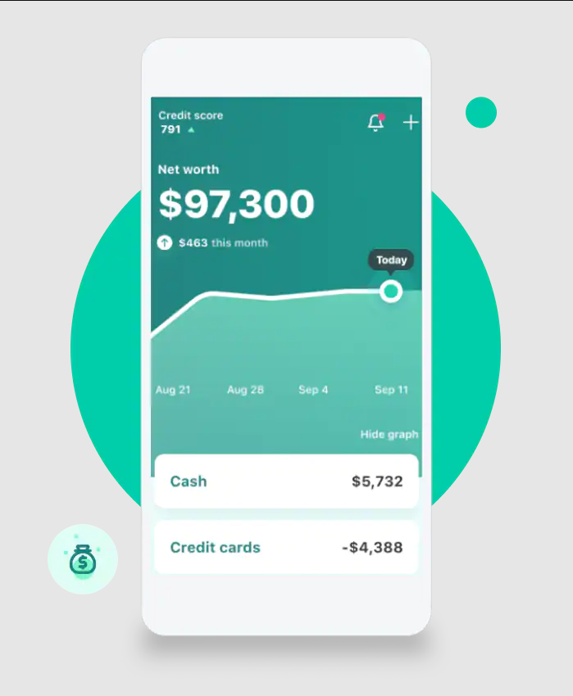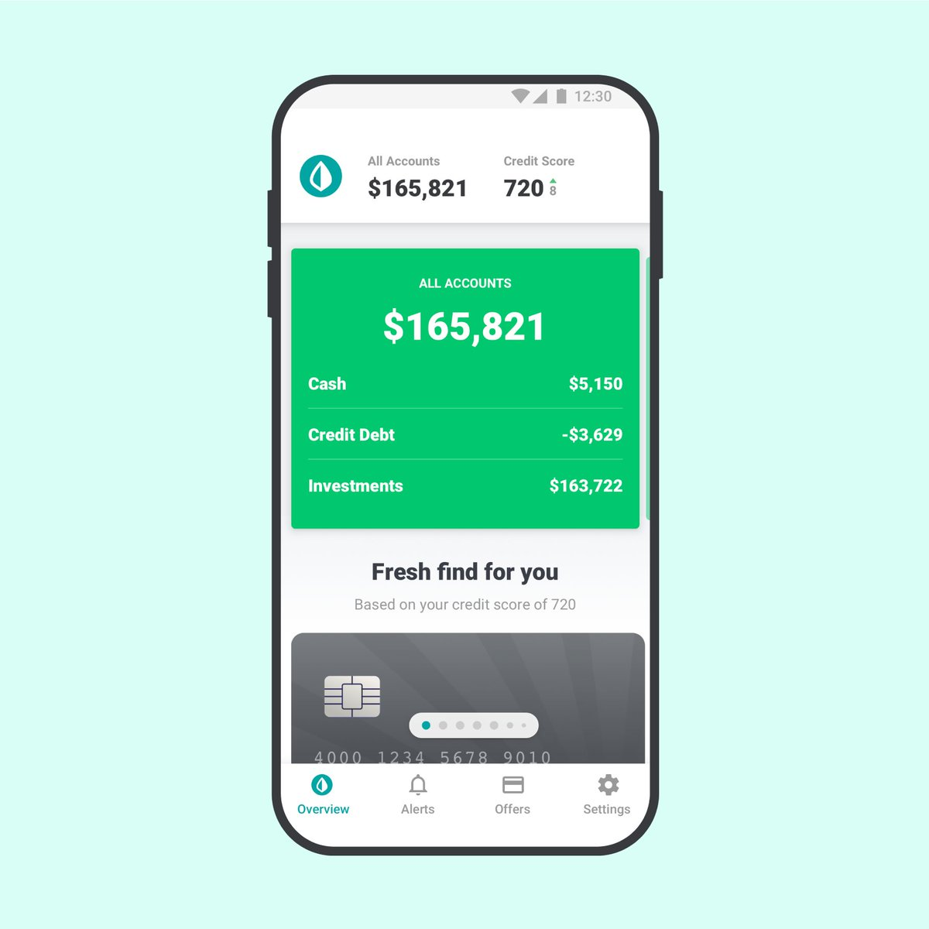

Figure 1:Similar System1: Mint1

Figure 2: Similar System1: Mint2

Above images are of the application mint. After analysis of those application, I found out that they requirement credit card or debit card in order to receive data from the user. In one way this is an advantage since the user does not need to input data as the application and their back account can always stay in sync but this also meant limitation since they could only work with around 10 banks and they were all limited to Canada and USA. Their targeted user base lied to those two specific countries and it will take a lot of time for them to adapt to all the banks in other countries to grow.

Since, this might be better but the targeted user base of the finance application is separate as anyone will have freedom to use it without entering any details and get freedom to later opt in if they want. There will be no partnership with bank because of which the users will have to enter the transaction and amount manually. This will lose integrity than the application mint but it will let my user base to be very scalable very quick without people having to enter their credit card details since not everyone is willing to pull their money at risk for a simple statistical analysis. In addition, specifically to sustaining integrity since not all transactions can be entered in the application there is a separate feature that lets you add correction to the visible amount.

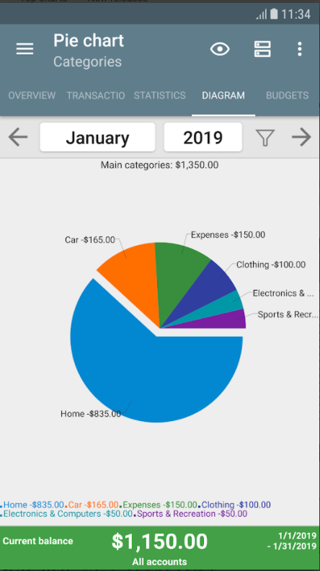

Figure 3: Similar System2: My Budget Book1

Another popular system available in Nepal is my budget book. This application is a paid application which provides a platform to manage transactions for the user but it lacks a good UI. This application is mostly targeted for recording the user’s income and expenses along with forecasting the balances. It provides features to statistically view the transactions in order to effectively save up on balance.

Along with a good UI the application also lacks auto categorization feature that will be present in the visioned application. The application will have a naïve bayes algorithm in order to categorize most natural text transactions into well defined categories. If the algorithm fails to recognize the category then the user can also override the prediction which will add to the training dataset making the algorithm better according the user’s personal preference.

## 4.3 Algorithm

### 4.3.1 Linear Regression

Linear regression is the supervised learning algorithm used in order to predict the next expenditure for the user. It will calculate a set of variables in order to calculate the output after figuring a relation between depending variables. The relation between the variables will be calculated using gradient descent whose core objective will be to reduce the RMSE value. The goal will be to generate a model that will create a personalized best fit regression line for the user in order to predict the next series of expenditure. (James, et al., 2021)

### 4.3.2 Naïve Bayes Algorithm

Naive bayes algorithm will be used in order to create a model that classifies natural text into categories by comparing it with a training data set. It will work on the Bayesian probability concept. The algorithm will be trained with a dataset that will contain words that are found in the text that belong to the category where the name of the category which will act as a label. (Luo, 2021)

# Artefacts

## 3.1 Features

The app is defined with two roles in order to define the functional requirements of the application constituting the user and a database. The user is visualized to be a singular person but can be further developed for a family or even an organization. The second role played is rather a database which would constitute both local storage and a server in order to constitute the functional capabilities to store user data.

The sole functionality for the mobile application will lie upon the financial tracking of the user with correspondence to the data that is fed. Furthermore, along with keeping the data intact and categorized, the data will also be analyzed for a better perception and comparison of the user’s personal incomes, savings and expenses featured with predictions and warnings in case of a potential overhead.

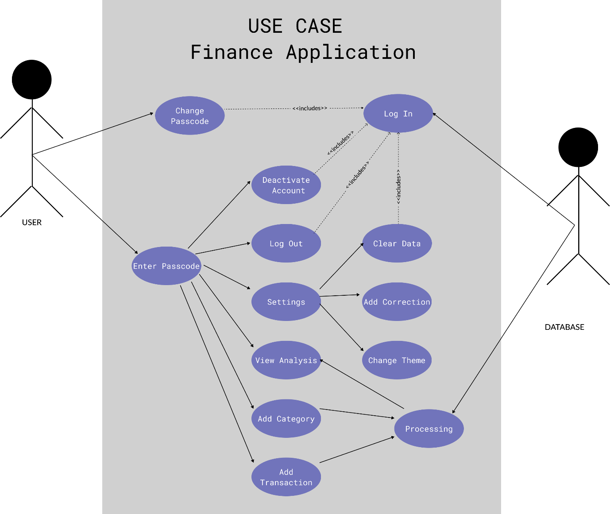

Figure 4: Functional Overview

## 4.2 Tools and Techniques

### 4.2.1 Flutter

Flutter is an open-source dart framework that will be used in order to code the front end for the application. Flutter is a cross platform tool that uses the concept of widgets. The application will be more focused on the android application but can be further implemented in web, desktop and iOS with least hassle because of its cross-platform property. Dart is the programming language used in this framework. It is known for capability for web rendering and handling animations efficiently which contributes in user experience and also decreasing the minimum requirements for the application.

### 4.2.2 MySQL

MySQL is an obvious choice since the entities in the database are related to each other. MySQL is a relational database management system that uses foreign key and primary key in order to provide data with respect to the query. It allows many built in functions such as count, unique and sort that generally removes the hassle to manipulate data in the APIs.

### 4.2.3 Django

Django is an open-source python framework which will be used to create APIs in order to access the MySQL database. The http APIs will render data in json format which can be accessed in our flutter application. Django is much supported by the developers and has detailed documentations along with a large supportive community. It has many built in library such as cryptographic hash function that will help in security for the developer.

### 4.2.4 Android Studio

Android Studio is one of the most popular IDE used for android development since it provides a built-in emulator which reduces the use for a third-party emulator. The emulator provides the versatility to choose the screen dimension and the android SDK version which allows for a better-quality software and distributed testing. Android Studio has a contrast color coding as well as shortcut keys that will allow for a faster development.

### 4.2.5 Firebase

Firebase is a backend application development software which will used in the application for token service APIs. It will provide access to authentication with google and Facebook in order to provide a bunch of user data which will be necessary when it comes to storing logs for the user. Firebase also provides a NoSQL database named Fire store which can also help in storing information about the user.

# Project Plan

## 5.1 Work Breakdown Structure

The finance system when broke down into smaller systems comprises of five systems. First one is the token auth system in which basis a user will be given their unique user ID. Using Facebook and google for user credentials will require firebase dependencies for this project. Secondly, money management will be about keeping track of all the transaction added by the user and having it tracked according to date for other systems.

Expense Prediction System will have a linear regression algorithm built from the past data of the user which will predict expenses for the next month according to the target saving set by the user. Auto categorization system will be an unsupervised machine learning model which will predict which category might the transaction fall into and determine whether the category is income or an expense. Lastly a detailed analysis will be provided so the user can take an informed decision.

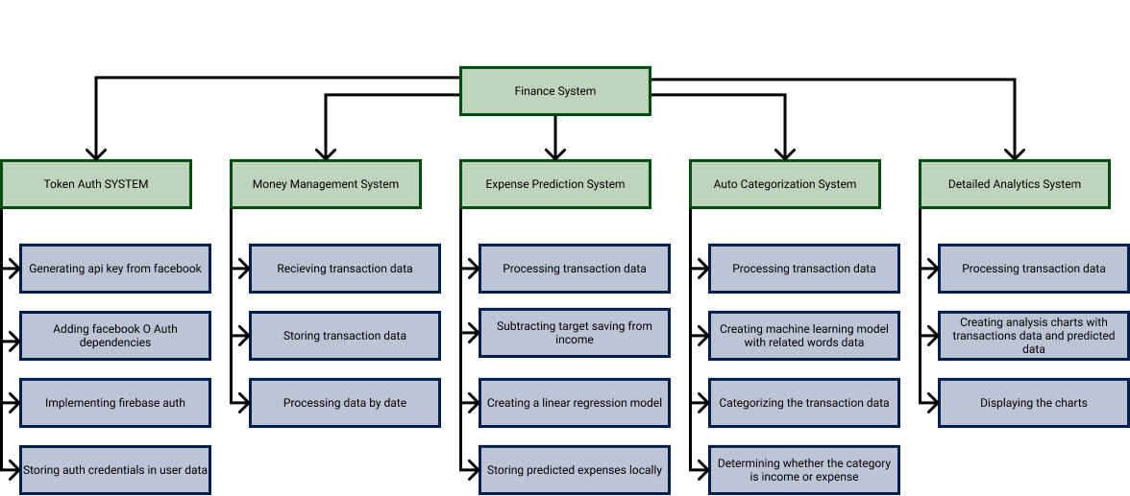

Figure 5: Hierarchical decomposition

## 5.2 Gantt Chart

The project management planning done is based on a two-sprint format in which way there will be room for progress even during late parts of the project. The activities have been scheduled on the basis of their impact on other activities, the priority of the activity and the time consumption for the activity. The Gantt chart below represents the planning done to complete this project in two sprints. The front end for the first sprint is given a lot more time than that of the second sprint whereas the back end for the second sprint has been given more time than that of the first sprint. This has been done so that more focus can be given to Artificial Intelligence when it comes to improvements and more focus to design and usability when it comes to minimum requirements for the application. 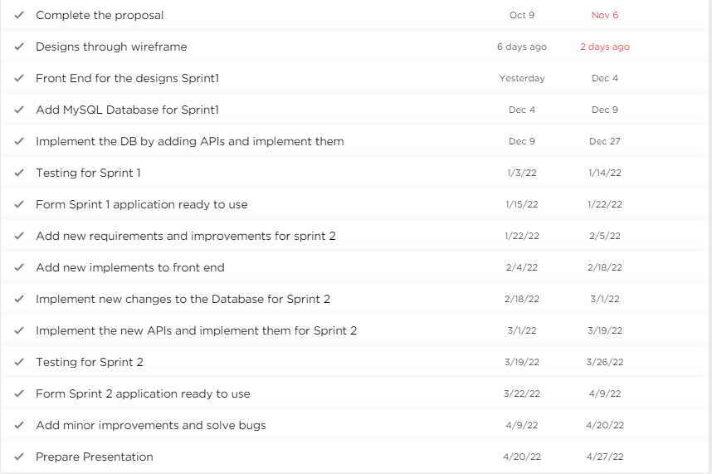

Figure 6: Timeline detailed view

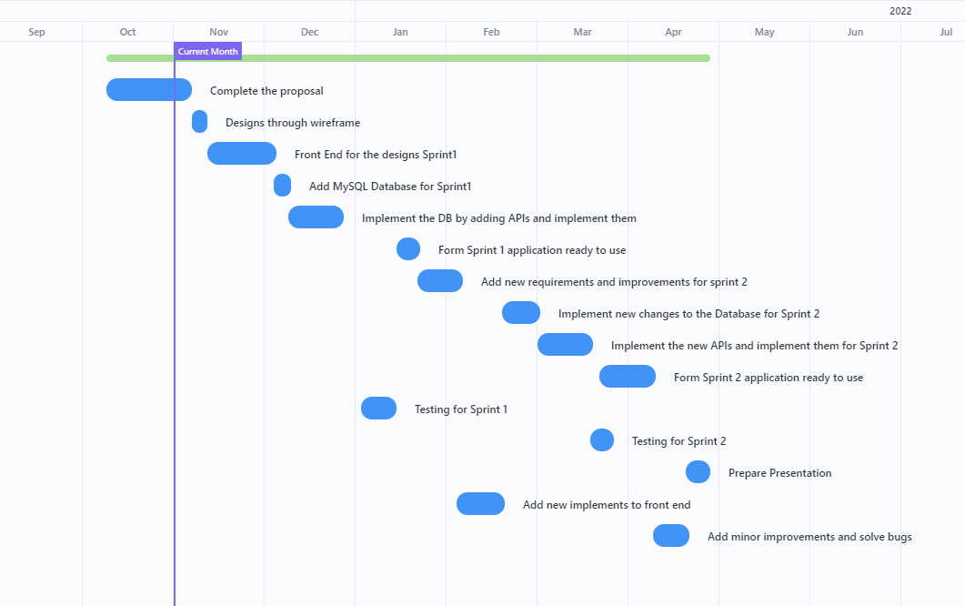

Figure 7: Timeline overview

# More Materials

## 6.1 Wireframe

### 6.1.1 Home Screen

Figure 8: Home Screen

The home screen of the finance application is the first screen seen by a user unless a passcode has not been set. This will constitute of a double line graph on the top card that will represent the predicted expense and the other graph will represent the actual expense for the user. The graphs will be drawn solely on basis of collective data of his personal past transactions occurred for last few months.

The bottom card will consist of tab view for expenses and incomes that will constitute of a categorized dataset of transactions performed by the user.

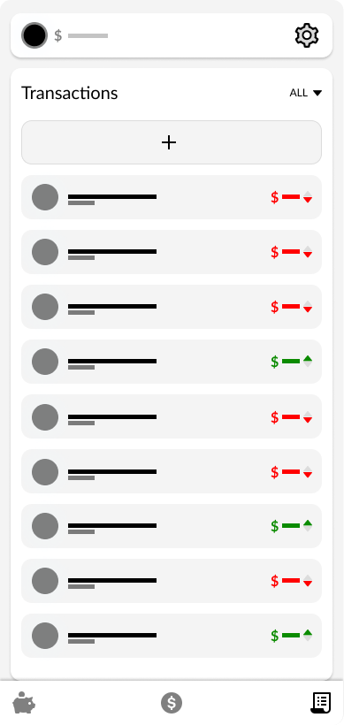

Figure 9: Transaction Screen

### 6.1.2 Transaction Screen

Transaction screen is the third screen on the bottom navigation bar and it provides list of all the transactions sorted descending by the most recently added ones. This will have a drop-down button in order to filter out the list. The transactions that are allocated as expenses are denoted in red and incomes are therefore denoted in green to represent the rise or fall in the overall balance of the user along with the amount by which it acted.

The header on the top most part of the screen represents the balance of the person along with his avatar and a button to navigate to the settings screen.

### 6.1.3 Category Screen

Figure 10: Category Screen

The category screen lists out all of the categories that are present. The application will categorize the natural language text entered by the user as transactions. This will be highlighted red in case an expense category overhead the prediction or highlighted green in case an income category overhead the prediction. Similarly, the user is given freedom to add a category manually by clicking the add button. This list will be sorted in descending order by the amount of the transaction.

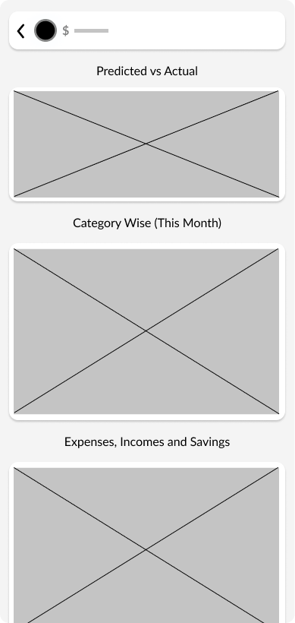

Figure 11: Analysis Screen

### 6.1.4 Analysis Screen

Analysis screen can be navigated by clicking on the graph on the home screen and it consists of three graphs that will help the user analyze the personal expenses. The first one will consist of the double line graph that helps the user compare his actual expenses with the predicted expense.

Similarly, the second card will have a pie chart that will represent the expenses category wise so that he can make a more informed decision to cut his expenses.

Lastly, the third card will represent a radar chart that will help compare the user’s expenses with income and savings for actual data compared with predicted data and data from last month.

### 6.1.5 Setting Screen

Figure 12: Setting Screen

The settings screen can be navigated through header and it will have personal preferences for the user like changing the theme of the app, changing the passcode, clearing the data, adding correction, deactivating the account and changing the avatar.

The user will also be able to change personal details like setting the target saving, bank balance or name. Lastly the user will also be given an option to log out from the account.

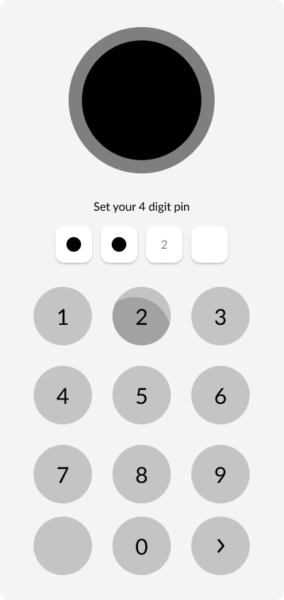

Figure 13: Lock Screen

### 6.1.6 Lock Screen

Since the application is supposed to have delicate financial details, a lock screen is to be added for security purposes. Setting a lock screen can be navigated through the settings screen and it is protected by a 4-digit number pattern.

The user can set the application to delete it’s contains in case for a brute force attempt. If a passcode is set then the screen will be shown at every launch causing it to protect the application from data theft.

# Conclusion

The provided designs are solely based upon the feature set targeted which might differ to the actual outcome as new features can be added or more effective methodologies may be encountered during the time period of this project. Agile methodology will be followed by which the project will be divided into sprints and will be open to any new improvements. The wireframe is roughly representing the envisioned front end for the application, the use case diagram represents the functional overview for the application whereas the sequence diagram signifies the interaction between the objects. Lastly, the work breakdown structure indicates different forms of systems that makes this project as a whole.

In conclusion, the diagrams and descriptions represent a finance application that assists you economically to make a much more informed decision about where and when to cut your costs to gain a target saving according to your own personalized data model.

# References

Brien, S. O., 2019. Consumers overspend by $7400 a year. *CNBC.*

Irons, R., 2019. *The Fundamental Principles of Finance.* s.l.:Routledge.

James, G., Witten, D., Hastie, T. & Tibshirani, R., 2021. *Linear Regression: An Introduction to statistical learning.* New York: Springer.

Luo, X., 2021. Efficient English text classification using selected Machine Learning Techniques. *Alexandria Engineering Journal,* pp. 3401-3409.

shalizi, c., 2004. *Quantitative Finance.* s.l.:s.n.